Artériographie carotidienne

Phase artérielle

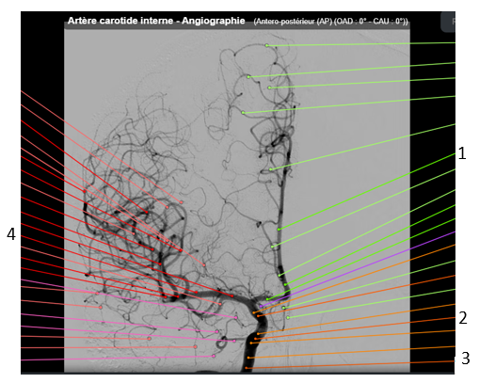

|  |  |
| --- | --- |
| 1. | 3. |
| 2. | 4. |

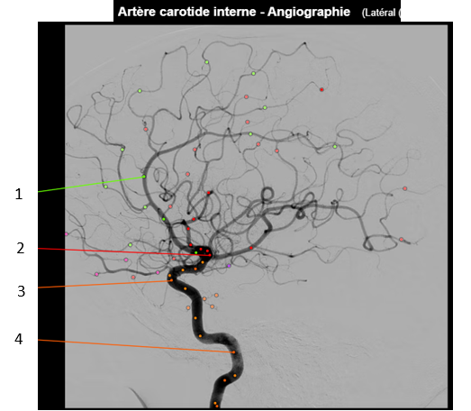

|  |  |
| --- | --- |
| 1. | 3. |
| 2. | 4. |

**Phase veineuse**

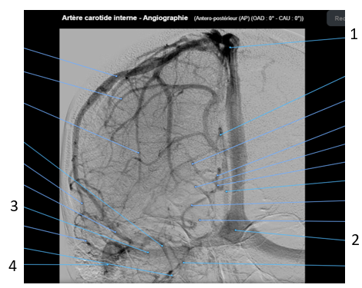

|  |  |
| --- | --- |
| 1. | 3. |
| 2. | 4. |

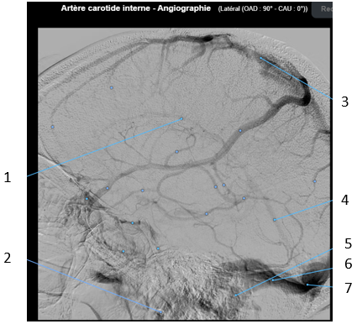

|  |  |
| --- | --- |
| 1. | 5. |
| 2. | 6. |
| 3. | 7. |
| 4. |  |

Artériographie vertébrale

**Phase artérielle**

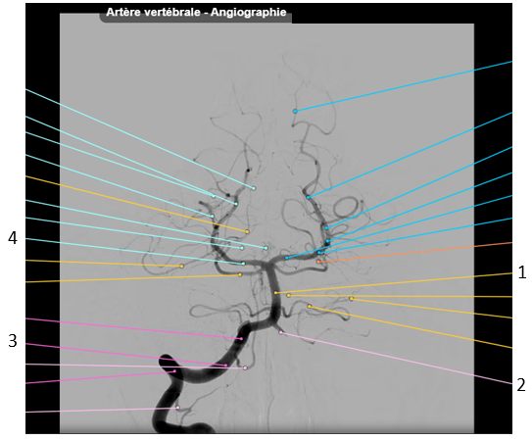

|  |  |
| --- | --- |
| 1. | 3. |
| 2. | 4. |

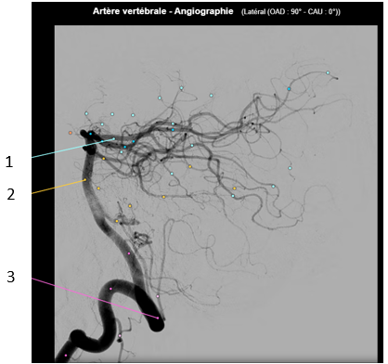

|  |  |
| --- | --- |
| 1. | 3. |
| 2. |  |

**Phase veineuse**

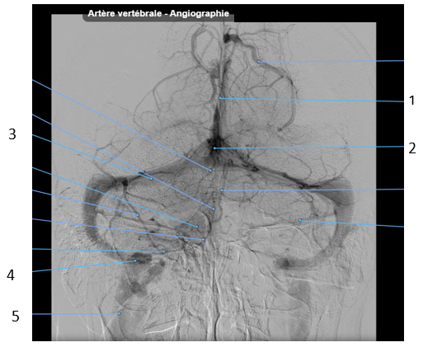

|  |  |
| --- | --- |
| 1. | 4. |
| 2. | 5. |
| 3. |  |

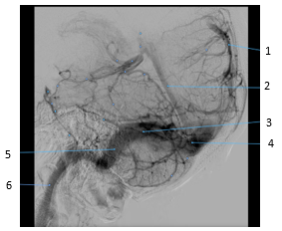

|  |  |
| --- | --- |
| 1. | 4. |
| 2. | 5. |
| 3. | 6. |

Images tirées de Micheau A, Hoa D, e-Anatomy, [www.imaios.com](http://www.imaios.com/), DOI: 10.37019/e-anatomy