1. Identifiez les artères.

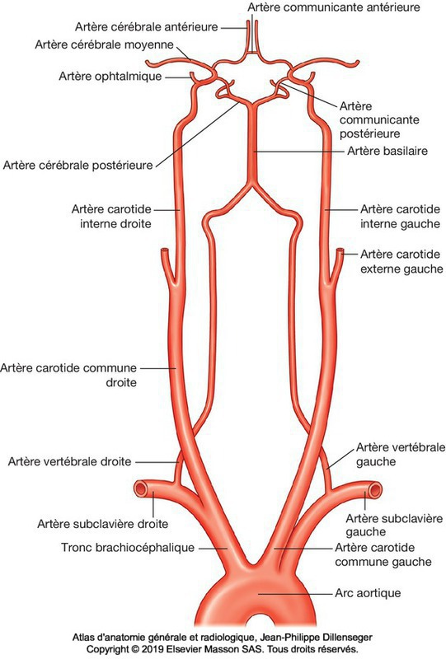

1. __________________________________

2. __________________________________

3. __________________________________

4. __________________________________

5. __________________________________

6. __________________________________

7. __________________________________

8. __________________________________

9. __________________________________

8

9

7

6

5

4

3

2

1

1

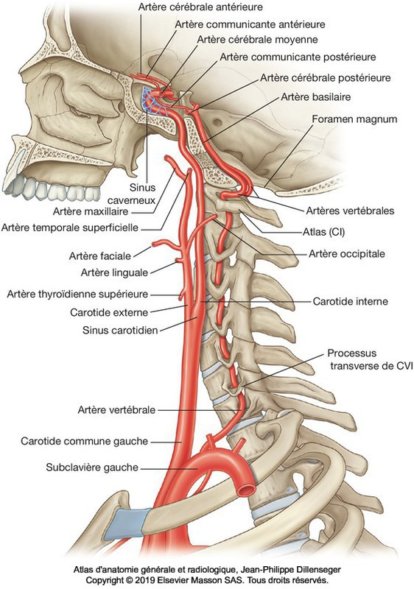

1. __________________________________

2. __________________________________

3. __________________________________

4. __________________________________

5. __________________________________

6. __________________________________

7. __________________________________

7

6

5

4

3

2

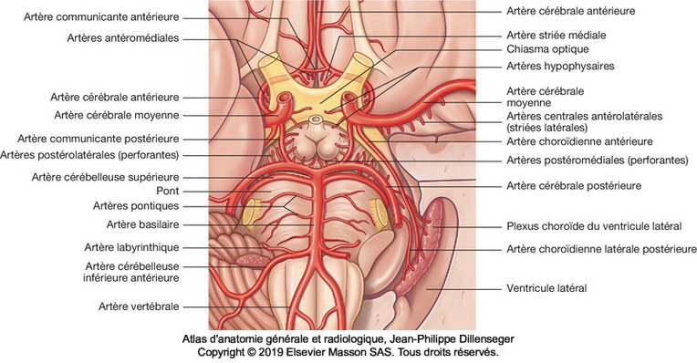

1. __________________________________

2. __________________________________

3. __________________________________

4. __________________________________

5. __________________________________

5

4

3

2

2

1

1

2. Identifiez les veines.

1. __________________________________

2. __________________________________

3. __________________________________

4. __________________________________

5. __________________________________

6. __________________________________

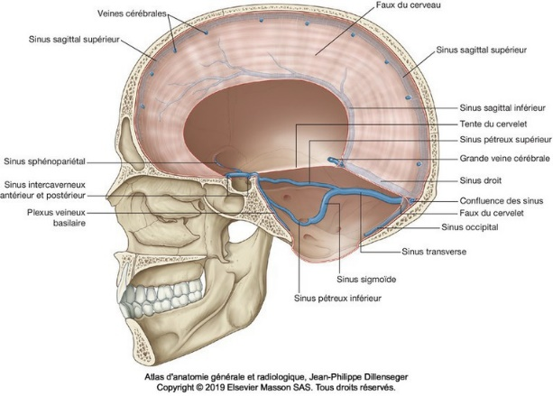

6

5

4

3

2

1

1

3. Complétez.

A) Le sang veineux crânien se déverse dans la veine ________________________________.

B) La veine jugulaire interne et la veine subclavière s’unissent et forment la veine _________________________.